Responding to Informational Text  Tell 3 facts you learned from reading the passage.   | Responding to Informational Text  Tell why you think someone would read this passage.
Responding to Informational Text  Where could you find more information about this topic? | Responding to Informational Text  Find 2 words that are defined in the passage Tell what they are and what you mean.
Responding to Informational Text  What is the passage mostly about? | Responding to Informational Text  Compare two ideas that are discussed in the passage.
Responding to Informational Text  Tell one sentence that would best summarize the beginning of the passage. | Responding to Informational Text  Find an unfamiliar word in the passage. Tell what you think it means. Why do you think so?
Responding to Informational Text  How did the author organize the information in the passage? (chronological, compare/contrast, definition/information) | Responding to Informational Text  Look at the titles, subtitles, pictures, and captions in the passage. What can you learn from them?
Responding to Informational Text  Pretend you have to teach what you learned from reading this passage to a new student. What will you teach him about the topic? | Responding to Informational Text  Choose a color to describe the topic. Tell why you chose it.
Responding to Informational Text  If you could create a sound to describe the topic what would it be? Why? | Responding to Informational Text  What information did you already know about the topic before reading the passage? How did you learn this information?
Responding to Informational Text  A title for a fiction book about this topic might be – …  Explain your thinking. | Responding to Informational Text  What did you find surprising about the facts introduced in the passage? What would you like to know more about? Why?
Responding to Informational Text  Did the passage leave you with unanswered questions? If so, what are they? | Responding to Informational Text  Does the author try to persuade you in anyway? Recall an example in the passage.
Responding to Informational Text  Does the author offer an opinion in the passage? Find an example of the author’s opinion in the passage. | Responding to Informational Text  Does the author present information in a way that is interesting? If so, how does he or she achieve this?
Response Cards for INFORMATIONAL TEXT  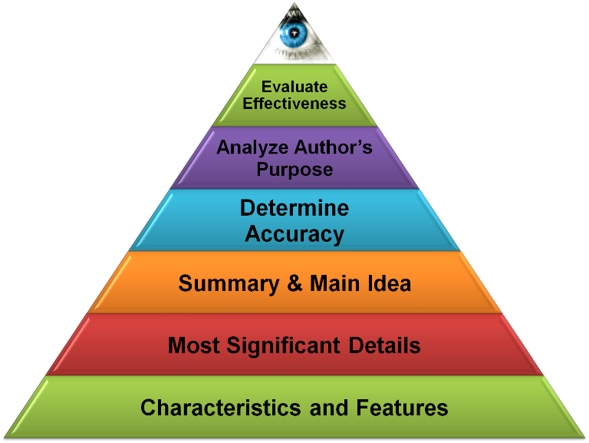  Revised to align with new standards  Dan Mulligan, flexiblecreativity.com | Response Cards for INFORMATIONAL TEXT  Revised to align with new standards  Dan Mulligan, flexiblecreativity.com
Response Cards for INFORMATIONAL TEXT  Revised to align with new standards  Dan Mulligan, flexiblecreativity.com | Response Cards for INFORMATIONAL TEXT  Revised to align with new standards  Dan Mulligan, flexiblecreativity.com

