Global Awareness and Collaboration Websites for Students & Teachers of History
- http://www.historyteacher.net/ 2. http://connected.socialstudies.org/Home/
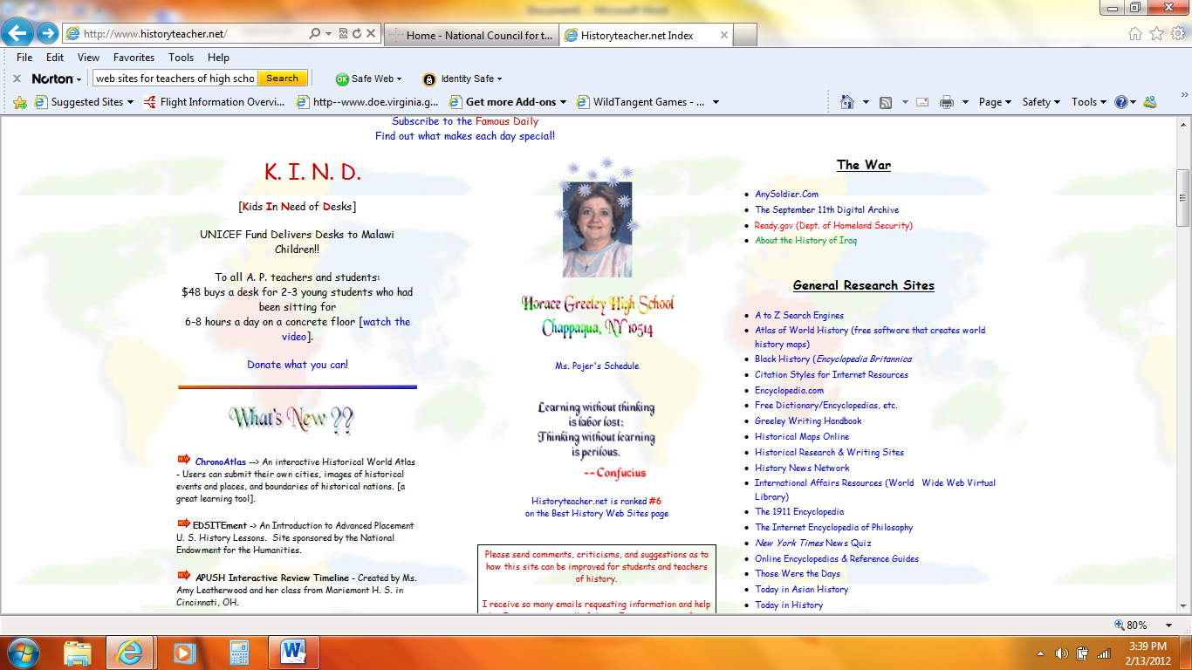

- http://epals.com 4. http://education.skype.com/projects/1913
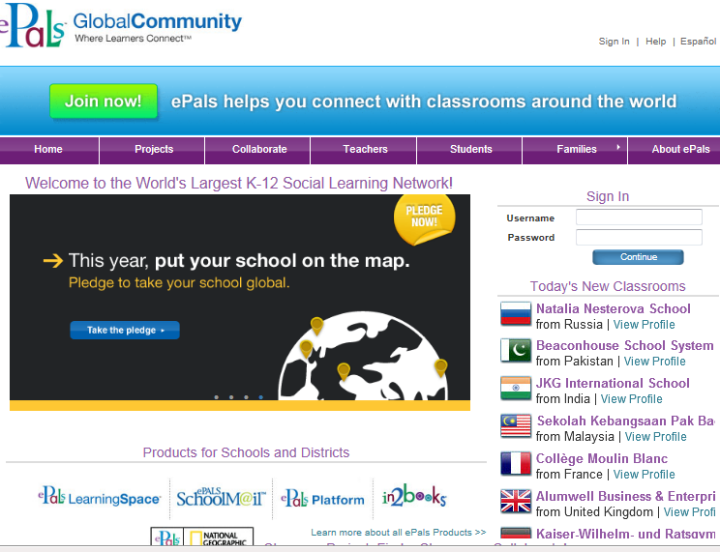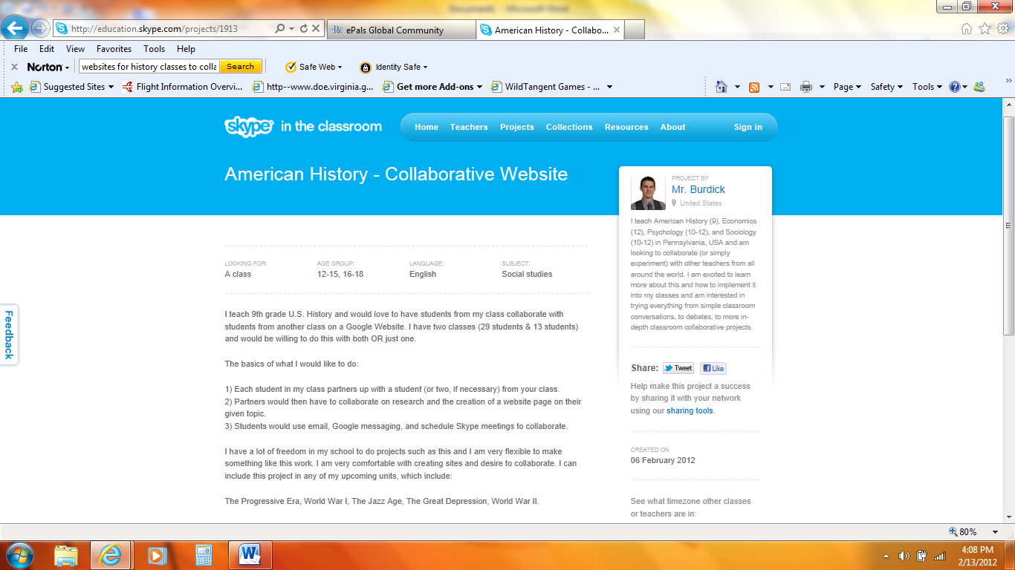

- http://thwt.org/index.php/discussion-collaboration/wikis 6. http://www.iearn.org/
